**Trend’s Pages and their respective API’s we use.**

Sales trends

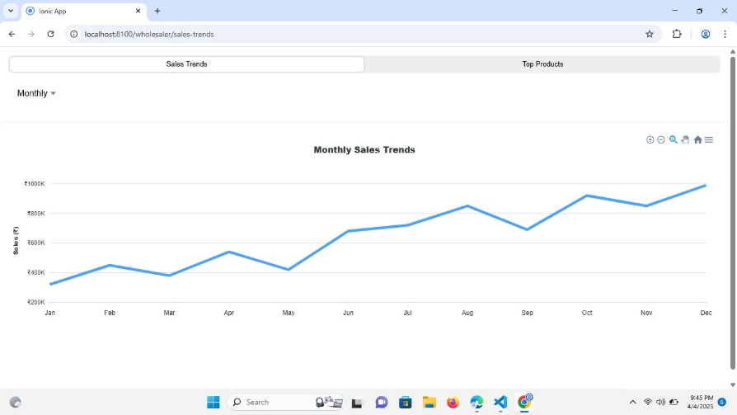

Sales trends 🡪

1. getSalesValue/monthly
2. getSalesValue/weekly
3. getSalesValue/yearly

Top selling

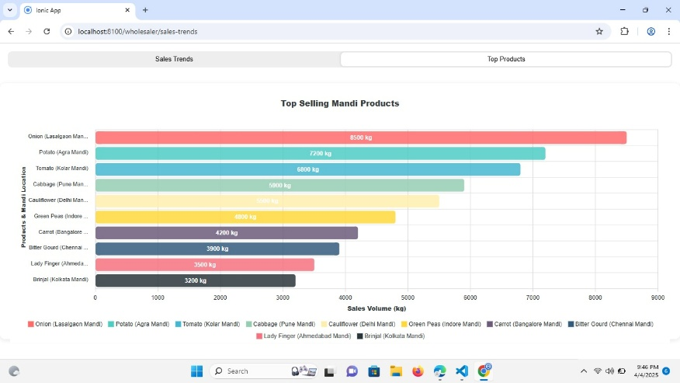

1. getTopSellingWeekly
2. getTopSellingYearly
3. getTopSellingMonthly

Low stock

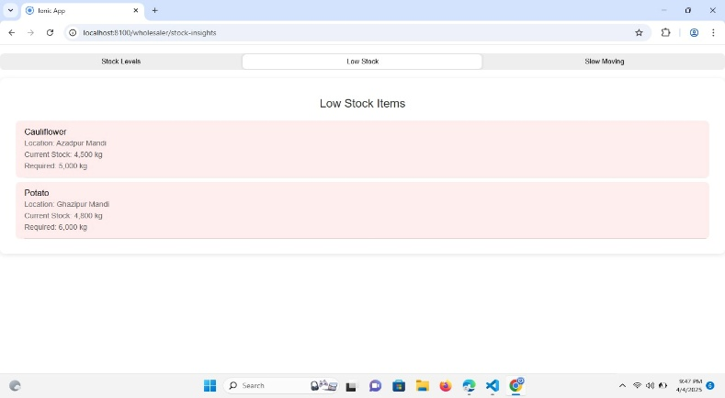

getLowStockItems

stock level per mandi

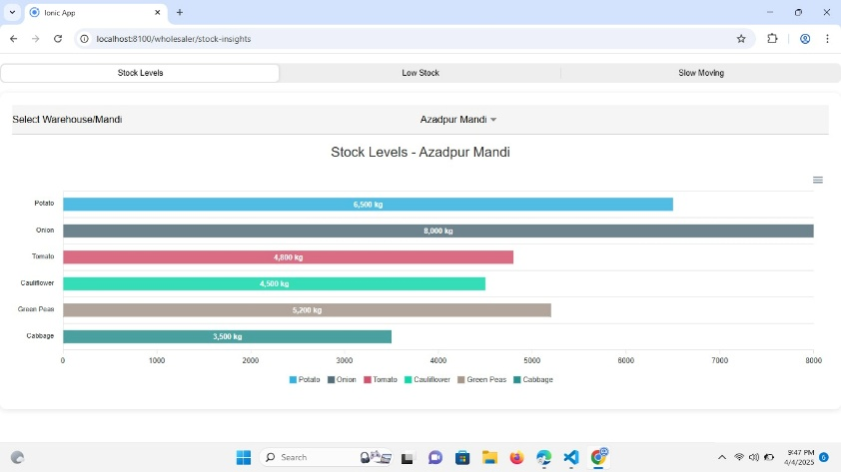

getCurrentStockByMandi/:mandi_id 🡪 Will display all the products wrt mandi_id

price comparision

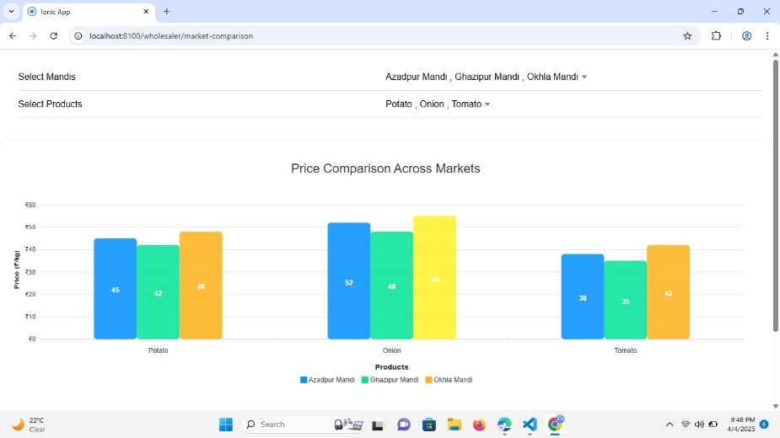

/getWholesellerPriceComparison?product_ids=2,3 🡪 product comparision

Bulk orders

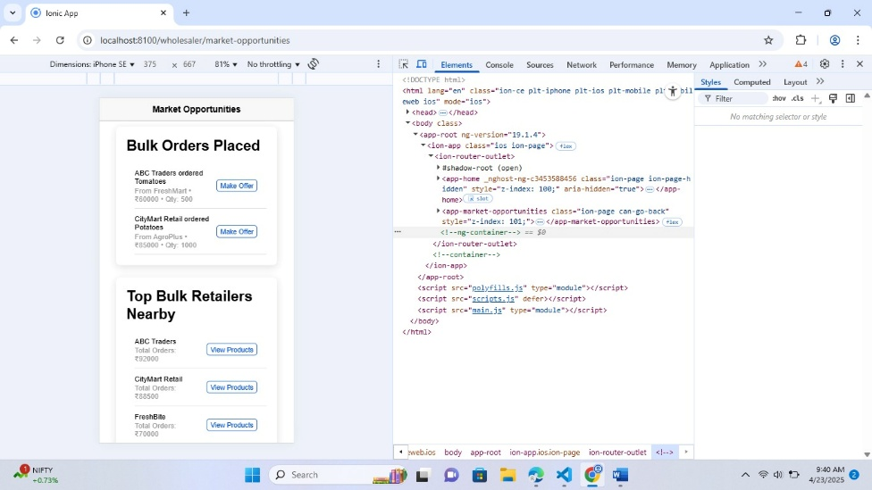

getAllBulkOrderDetails 🡪 Bulk order’s placed

Top products to restock

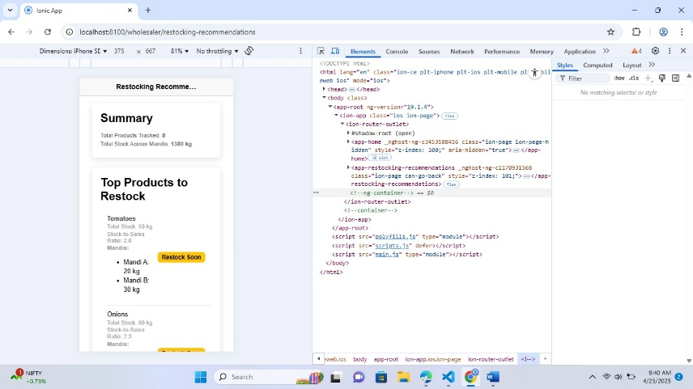

getReStockProductsHandler 🡪 top Products to restock

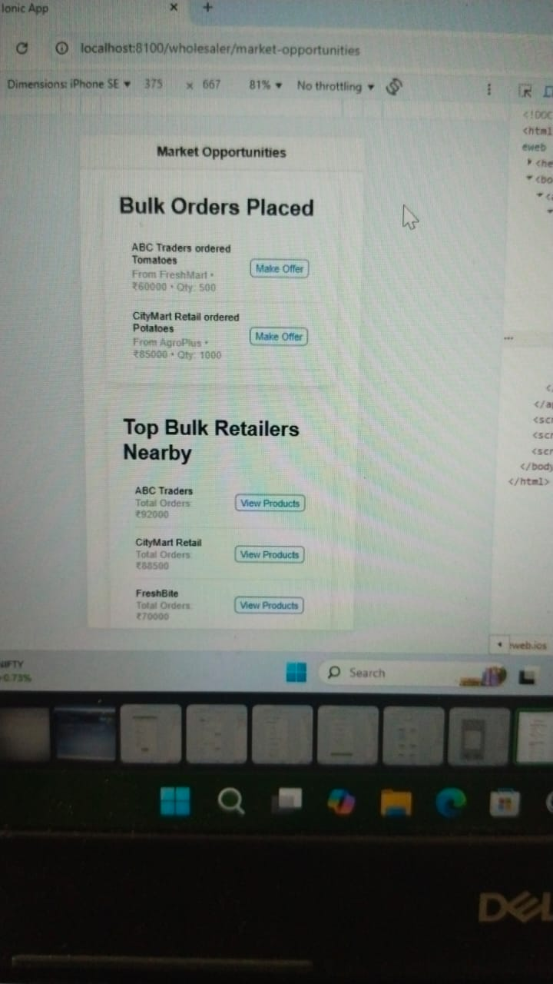Top Bulk retailers nearby   
  
/getTopRetailerDetails